**Assignment 10**

**Deploy a project from GitHub to EC2 by creating new security group and user data.**

**Steps for deploying project from github to EC2:**

1. **Sign in.** Sign in to your **GitHub and AWS account**.
2. After that go to **EC2 Dashboard** in your aws and click on **Security groups**.

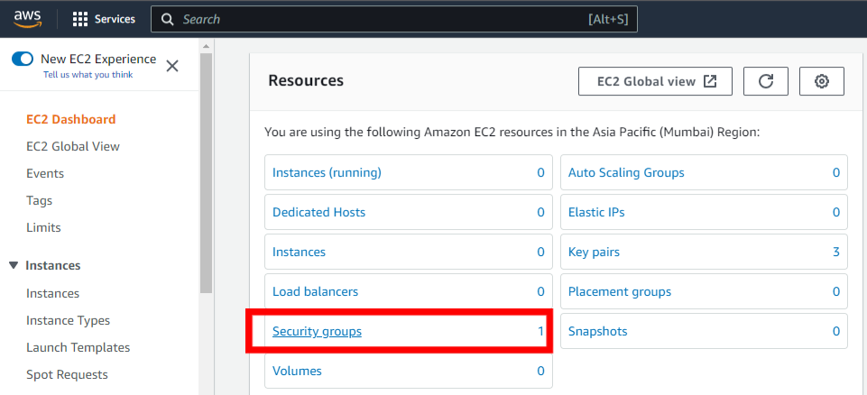

1. **After that click on Create Security group to create a new security group.**

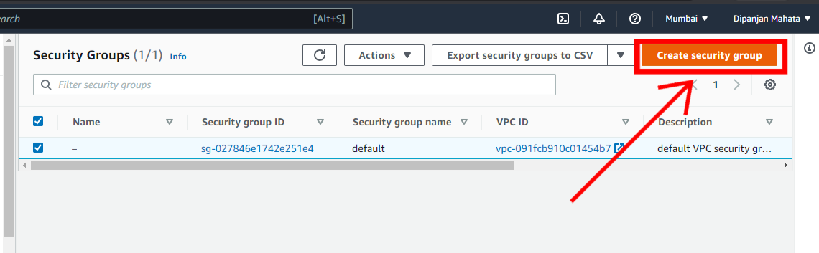

1. **Now enter security group name and description about the group.**

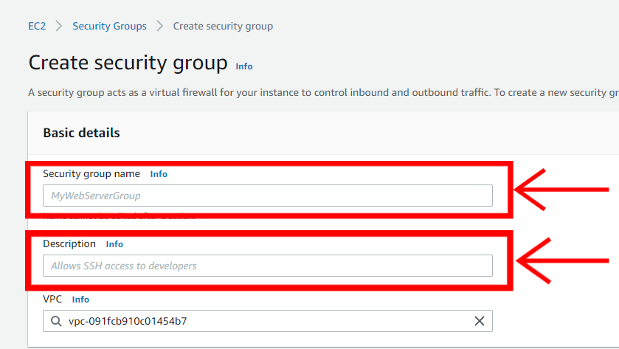

1. **In the Inbound click on add rule to insert rules for the security group.**

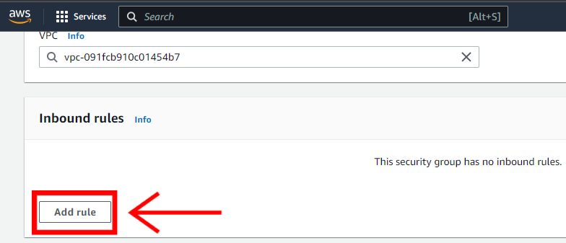

1. **In this assignment we are inserting 4 rules Custom TCP, SSH, HTTP, HTTPS.**

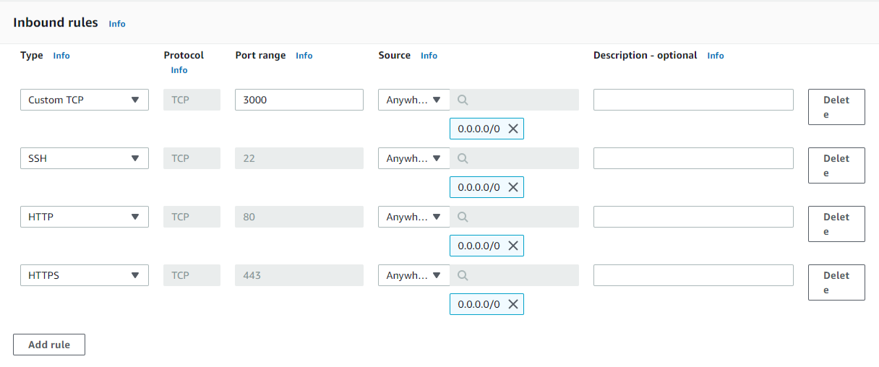

1. **After that just click on Create security group to create the security group.**

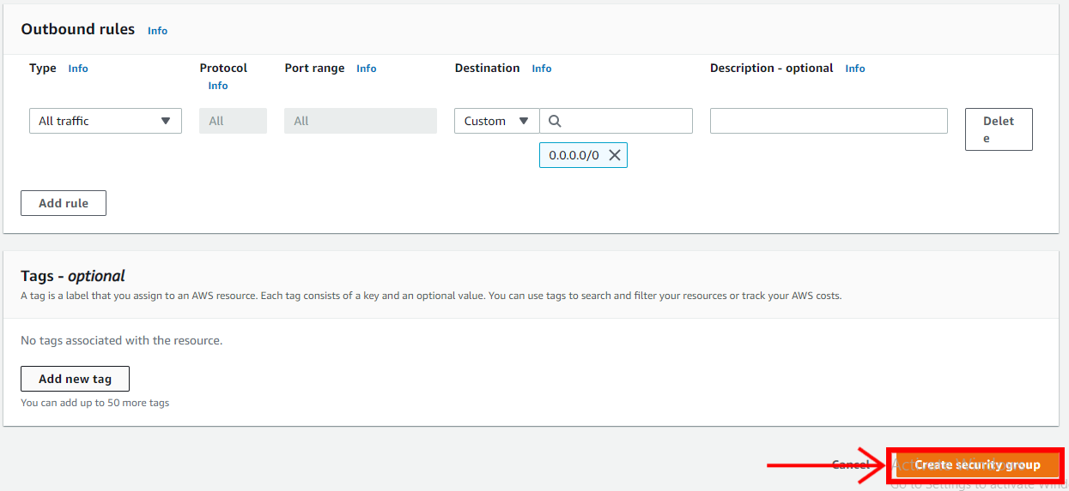

1. **After that launch an EC2 instance.**

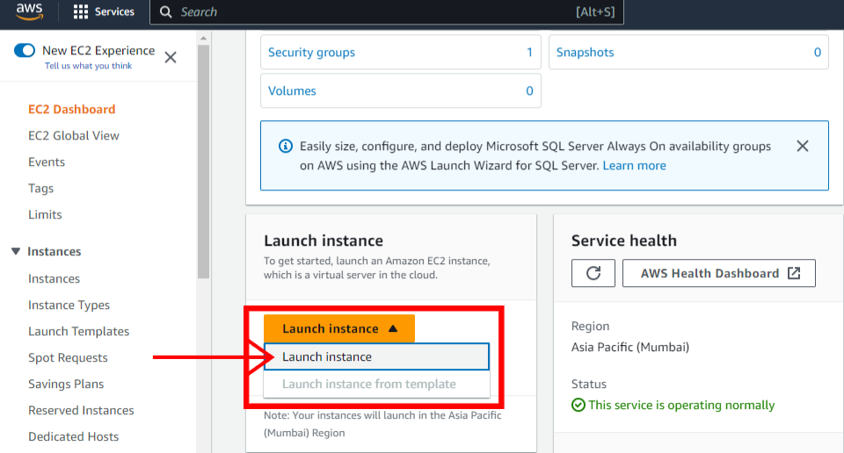

1. **During launching Select existing security group to select the select the security group you have created just now.**

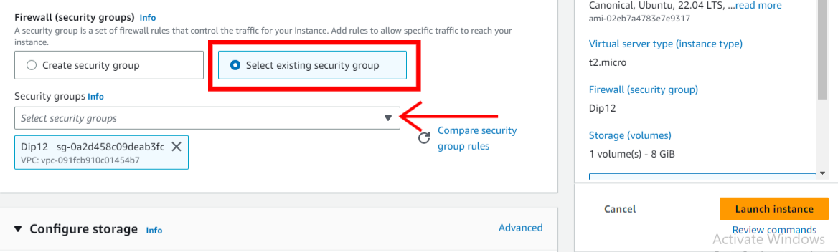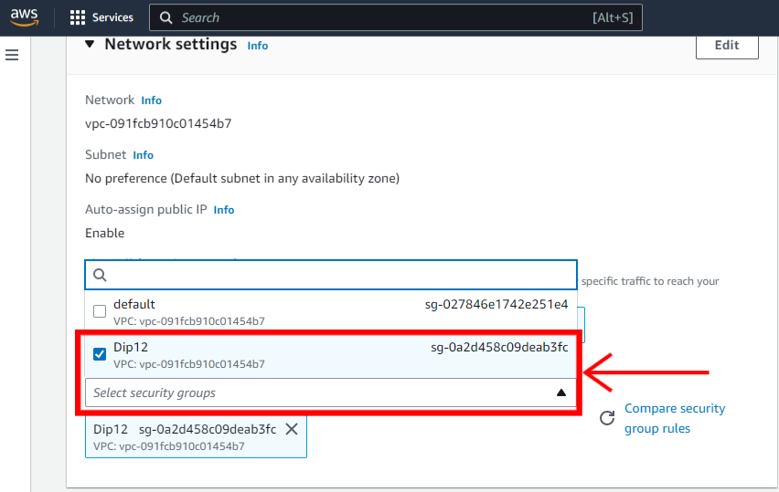

1. **After that click on Advance details.**

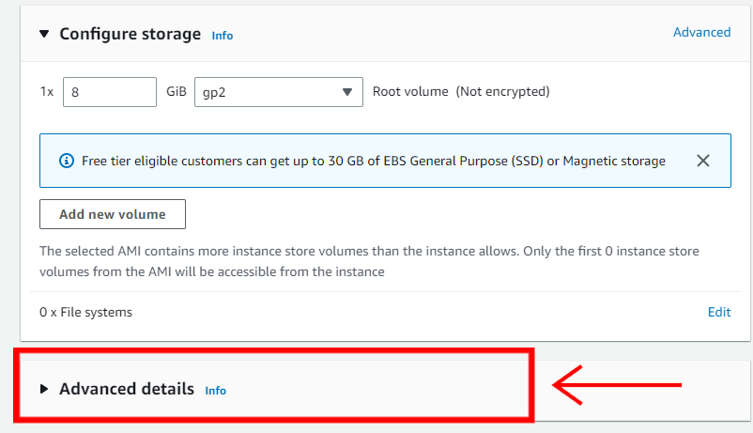

1. **In the advance details section, at the bottom we have user data wher we have to write the commands. Which are:-**

**#!/bin/bash**

**apt-get update**

**apt-get install -y nginx**

**systemct1 start nginx**

**systemct1 enable nginx**

**apt-get install -y git**

**curl -sl https://deb.nodesource.com/setup_16.x | sudo -E bash -**

**apt-get install -y nodejs**

**git clone https://github.com/Dipanjan2088/AWS-Dip-.git**

**cd New-Repo1**

**npm install**

**node index.js**

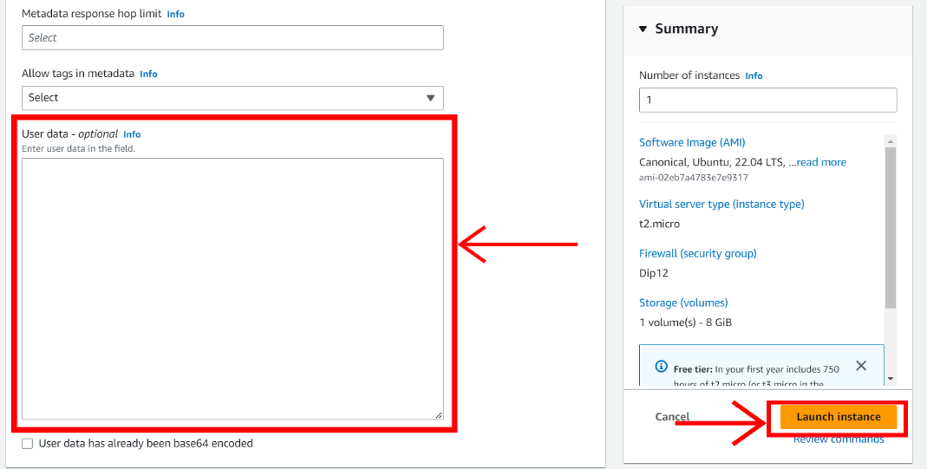

1. **And then launch the instance.**
2. Now, before starting the server we have to add port number as in index.js file the port is 4000.so we need to add that.
3. Now, copy that ec2 IPv4 address and paste it in a new tab with **: 4000** and by clicking we can run the website.

